20 YEARS OF THE LIEE-NTUA ERMOUPOLIS SEMINAR: AN INSTITUTION THAT STANDS THE TEST OF TIME
20^{Ο} ERMOUPOLIS SEMINAR
Faithful to its appointment with the capital of Cyclades for the 20th consecutive year, the Ermoupolis Seminar on the Information Society & Knowledge Economy, organized every year by the Laboratory of Industrial & Energy Economics of NTUA, opens its doors to the public from the afternoon of Thursday 10 July to the morning of Sunday 13 July at the Conference Hall "Valma" of the Cyclades Chamber of Commerce.

THEME
The Seminar has been held for one three-day period every July since 2006 as part of the Annual Seminars of Hermoupolis organised by the Institute of Historical Research of the National Hellenic Research Foundation (IHU/EIE) since 1984.
On the occasion of the 20th anniversary of the seminar, the scientific-organizing committee decided this year to take stock of the seminar, highlighting the temporal continuity and development of the thematic fields it deals with.
In this context, during the introductory session of the Seminar (Thursday afternoon), greetings will be given by the Rector of NTUA, Ioannis Xatzigeorgiou, the Vice Rector of the University of the Aegean, Petros Kavassalis, and the President of the Chamber of Cyclades, Ioannis Roussos. Afterwards, Yannis Kalogirou, Professor Emeritus of NTUA and former Director of EBEO, will give a historical review of the Seminars from 2006 until today, of which he was co-founder together with Theodoros Karounos and Panagiotis Panagiotopoulos. This will be followed by the keynote speech of Per Alex Sørensen, co-founder of the Danish company PlanEnergi, who has extensive experience in the renewable energy sector, entitled "Status of climate change and technical solutions".
The 4 main sessions of the Seminar will take place in the morning and afternoon of Friday and Saturday. The first session (Friday morning) is dedicated to the highly topical issue of artificial intelligence and the challenges arising from its use in various fields of application such as education and research, production processes and business operations, public administration and other public organisations. Among others, speeches will be delivered by Timos Sellis, Director of the Archimedes Unit of the Athena Research Center, Andreas Bountouvis, Professor and former Rector of NTUA, Vassilis Maglaris, Professor Emeritus of NTUA, Manolis Koumantaros, Head of Innovation and CX at Kantar, and Alexios Zavras, Chief Open Source Compliance Officer of Intel Corp.
The second session (Friday afternoon) will focus on regional development policies with emphasis on island regions. Speakers will include Michalis Goumas, an official of the Ministry of National Economy and Finance, Vrasidas Zavras, sustainable development consultant and former General Manager of Piraeus Bank, Yannis Spilanis, Director of the Laboratory for Local and Island Development of the University of the Aegean and local government officials. Local businesses will also participate in this session.
The third thematic section (Saturday morning) will feature speeches and interventions on the interconnection of the world of research with the world of production and society in general. Speakers include executives of Technology Transfer Offices of Greek Universities, such as Angelos Tsakanikas, Director of EBEO and Head of the Technology Transfer Office of NTUA, and Katerina Papadouli, Head of the Innovation, Entrepreneurship & Technology Transfer Office Innovinagri of the Agricultural University of Athens. Also, founders/executives of start-ups (Metabolio, Local AI, V-Cube, StartPC) and Yiannis Anastasopoulos, Head of Microsoft's Education Sector for Greece, Cyprus and Malta, will speak. Speeches will also be given by Prodromos Tsiavos, Head of Digital and Innovation at the Onassis Foundation, and Artemis Yagou, researcher at the Deutsches Museum in Munich. Among the interventions will be that of Manos Matsanganis, Professor at the Polytechnic University of Milan.
The fourth thematic session (Saturday afternoon) will focus on the issue of productive reconstruction of the country in terms of sustainable development and will discuss issues such as the conditions for changing the production model and the utilization of modern technologies by domestic enterprises, and the structural reforms required. Speakers will include Tasos Anastasatos, General Manager at Eurobank, Dimitris Liakos, senior executive also at Eurobank, Yannis Kalogirou, Professor Emeritus of NTUA, and George Stephanopoulos, General Manager of the Association of Mobile Telephony Companies.
Finally, on Sunday morning the conclusions of the Seminar will be discussed.
See HERE the detailed Programme of the Seminar.

ORGANISATIONAL
Who are the organisers?
The 20th Ermoupolis Seminar on the Information Society & Knowledge Economy is organized by the INFOSTRAG Group of the Laboratory of Industrial and Energy Economics (LIEE) of NTUA, the Chamber of Cyclades, and the Research Unit in Artificial Intelligence "Archimedes" of Athena Research Center.
The Seminar is supported this year by Eurobank, KAS Greece - Cyprus Foundation, Break Even Consulting, the Technology Transfer Office of NTUA and the Open Technologies Organization - EELLAC.
The communication sponsor is Kerkyra-ECONOMIA PUBLISHING.
Where will it take place?
The Seminar will take place at the Conference Hall "Valma" of the Chamber of Cyclades and there will be the possibility of interactive participation through the Webex platform and live viewing through the channel of LIEE on YouTube.
Who is it for?
The seminar is addressed to and attracts a wide range of participants: People from the academic-research field (professors, researchers and students), executives of public administration, local government and other public organisations, executives of businesses and non-governmental organisations, founders of start-ups, people in public positions of responsibility, and other citizens interested in the issues addressed by the seminar.
Where do you register?
Fill in the registration form HERE

ORGANISERS
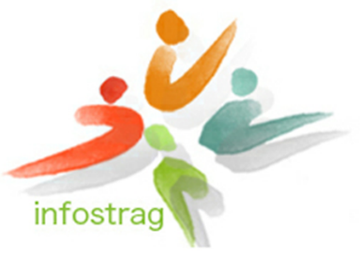
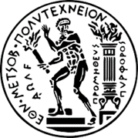



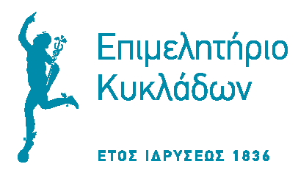

IN COOPERATION WITH


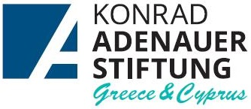

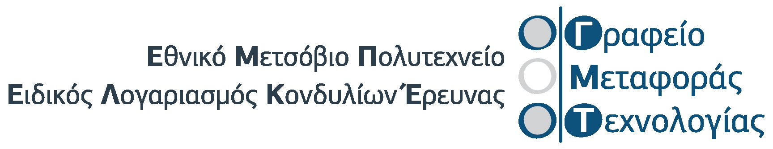

SPONSOR OF COMMUNICATION
