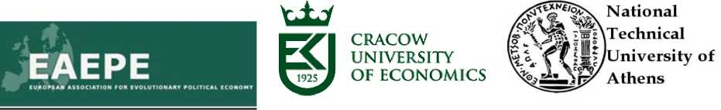
EAEPE Symposium 2016

The role of industrial policy in European re-industrialisation
Venue: Krakow, Campus of Cracow University of Economics
12th and 13th of May 2016
Program
Thursday 12th of May 2016
All day: Main Building (Budynek Gl0wny), 1st floor, room: Stara Aula
13.15-13.45 Welcome address: Rector of Cracow University of Economics
Introduction to the symposium: Ioanna Kastelli, National Technical University of Athens and Lukasz Mamica, Cracow University of Economics.
13.45- 14.45: First key note speech: Karl Aiginger,The Austrian Institute of Economic Research WIFO.“A new industrial policy for a dynamic, social and ecological Europe”. Chair: Lukasz Mamica, Cracow University of Economics.
(the keynote speech will be followed by discussion open to the audience)
- - 16.00:Panel discussion: What lessons can be learned from the economic crisis to implement a European industrial policy? Chair: Yannis Caloghirou, National Technical University of Athens.
Karl Aiginger , Professor, Director of The Austrian Institute of Economic Research WIFO. Tassos Giannitsis, Emeritus Professor, National Kapodistrian University of Athens, former minister.
Jerzy Hausner, Professor, Cracow University of Economics, former minister.
Robert Wade, Professor, London School of Economics and Political Science.
- - 17:30 1^{s} session: New challenges for industrial policy. Chair: Jonathan Feldman, Stockholm University
Constantine Collin Theoretical justifications for industrial policies: an update.
Yeoryios Stamboulis Vasiliki Mavroeidi
Industrial policy scope in the knowledge economy: embeddedness and flight of industry.
Industrial policy and global value chains: evidence from the
16.00 - 16.30 coffee break
electronics sector in Guangdong.
SOCIAL DINNER: h.20.00 Restaurant Malecon, Roof of the hotel Pod Wawelem, Pl. Na Groblach 22
Friday 13th of May 2016 All day: Pavilion G, room 13
- -10.30 Second key note speech: Robert H. Wade, London School of Economics. “The supportive context of effective industrial policy”. Chair: Ioanna Kastelli, National Technical University of Athens.
(the keynote speech will be followed by discussion open to the audience)
Yannis Caloghirou, Aggelos Tsakanikas
Olga Nosova
Piotr Feczko
Tomasz Geodecki, MaciejGrodzicki
- 11.45 2nd session: Industrial policy in different national contexts. Chair: Iurii Bazhal, National University of Kyiv-Mohyla Academy
The need for a new industrial policy to “innovate out of the crisis”: the case of Greece.
The impact of industrial policy on regional development in Ukraine.
The assumptions of pro-innovative industrial policy in Poland and China.
Product standards and dynamic comparative advantages. The case of boiler markets in Poland.
- - 12.15 coffee break
rd
12.15 - 13.30 3 session: Linking structural and technological issues to industrial development. Chair: Yeoryios Stamboulis, University of Thessaly.

Iurii Bazhal
Tassos Giannitsis, Ioanna Kastelli
Rauno Maekivi, Erkki Karo,V eikoLember
Jonathan Feldman
Terminology is significant: "Re-industrialization" versus "Innovation development".
Linking structural and technological change to industrial recovery in Greece.
Private sector participation in research, development and innovation policy: a technology perspective.
Enablers of green industrial policy.

13.30-14.30
lunch break
- 15.45 4th session: The role of interactive contexts in industrialisation. Chair: Tomasz Geodecki, Cracow University of Economics
Stamboulis Yeoryios, Stathaki Chrisi
Ryszard Cwiertniak
The many faces of proximity in innovation: a literature review.
Rules of cooperation between science and business in the area of smart specialization at the regional level: an attempt of evaluation.
Lukasz Mamica
Piotr Kopvcmski
Locally embedded reindustrialization through a system of students’ theses oriented to companies.
Financial university-industry interactions. Proposals on industrial policy.

- - 16.15 Discussion and conclusions
Notice: Each session includes 3 or 4 paper presentations and 15 minutes of discussion after the end of all presentations. The time schedule for each presentation is 15 minutes.
Saturday 14thof May 2016
10.00-12.00 Guided tour to Nowa Huta, socrealistic centre of heavy industry - a monument of architecture.

